1. **Getting Started** (How to log in into System)

Connect to the internet and go to the System site [www.chubi.cast.ac.jp](http://www.chubi.cast.ac.jp) .

Login information will be asked there

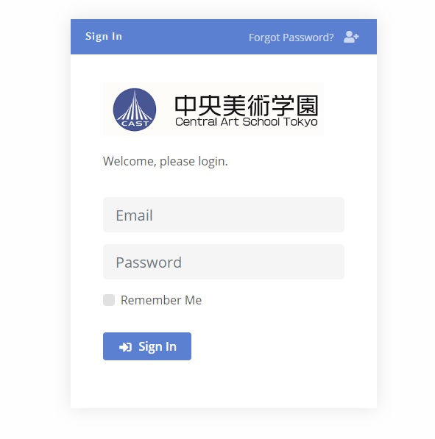

Type the email and password, Click Sign in button

1. **Introduction**
2. **Dashboard View**

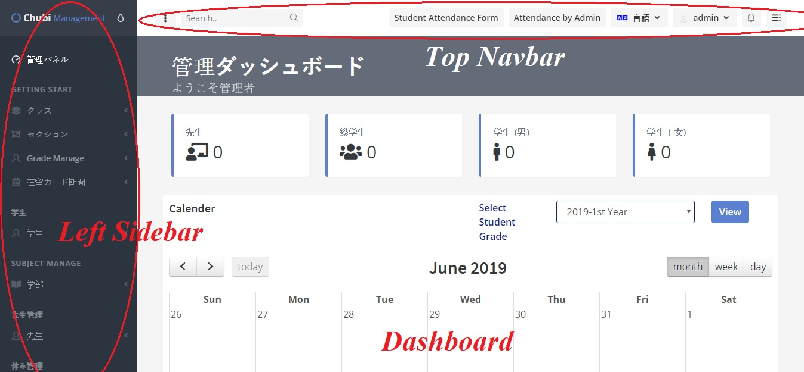

1. **Top Navbar Menu**

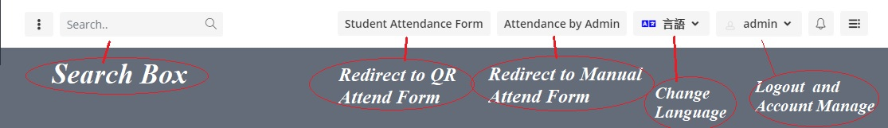

1. **Left Sidebar Menu**

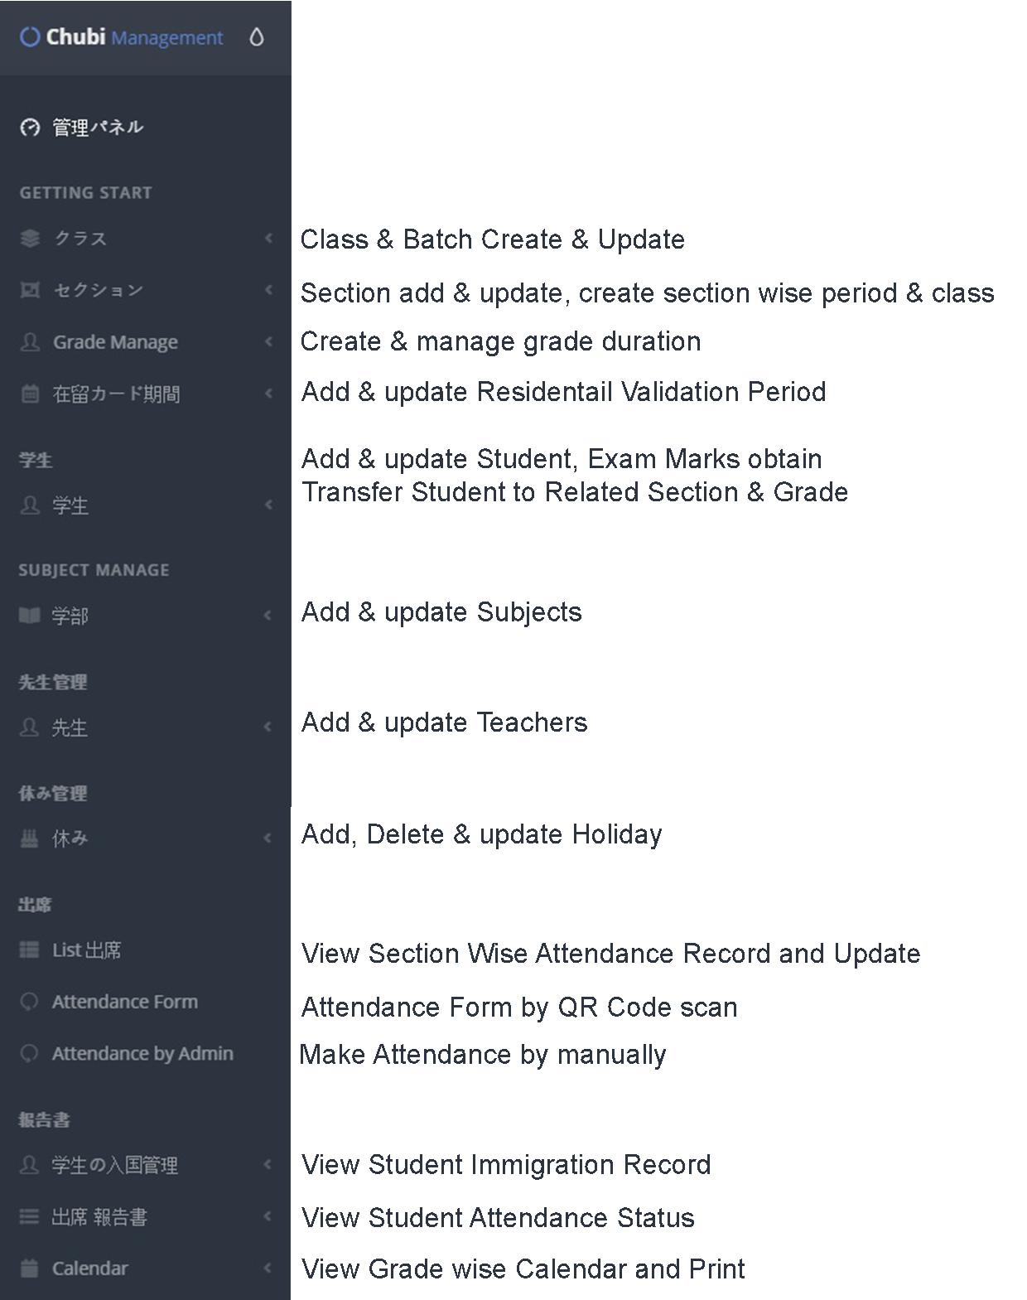

1. **Class/Batch Manage**

* Go to **Class/Batch** under **Getting Start** Heading
* Click Add Record
* Fill Form and Submit Separately for Create Year and Batch Year Group

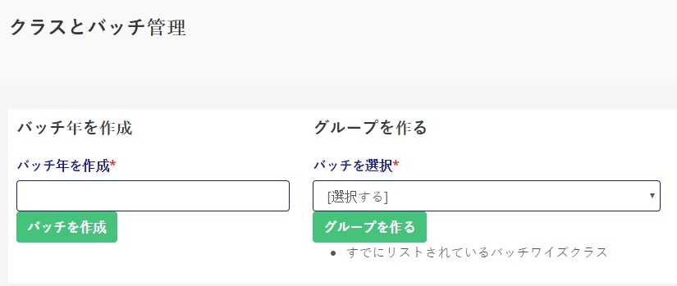

1. **Section Manage**

* **Add New Section**
* Go to **Section** under **Getting Start** Heading
* Click Add new section (If need to create new section)
* Fill form and submit

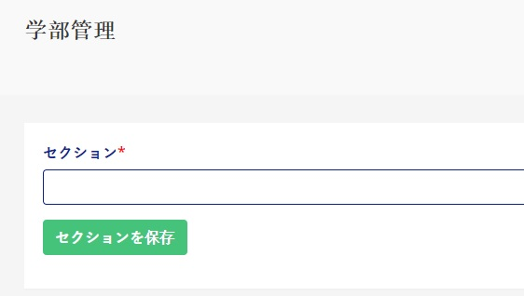

* **Class Wise Section**
* Go to **Section** under **Getting Start** Heading
* Click **Class Wise Section**
* Fill form and submit

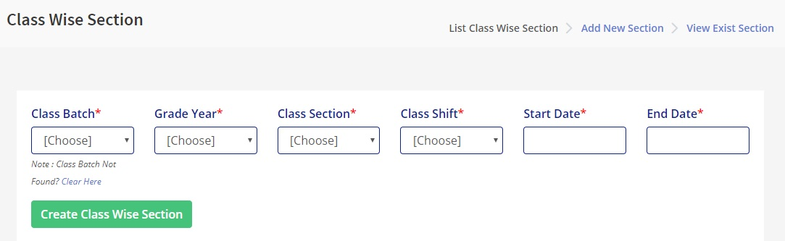

* **Section Wise Period**
* Go to **Section** under **Getting Start** Heading
* Click **Section Wise Period**
* Fill form and submit

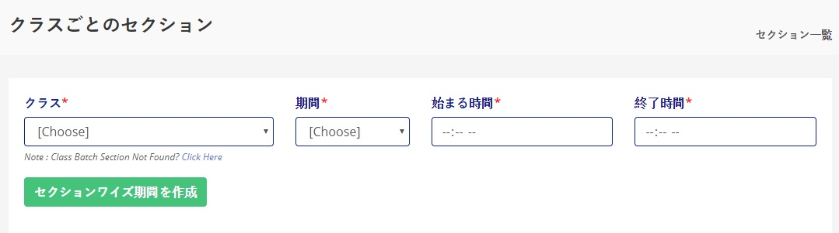

1. **Grade Manage**

* Go to **Grade Manage** under **Getting Start** Heading
* Click **Grade Duration Manage**
* Fill Form and Submit

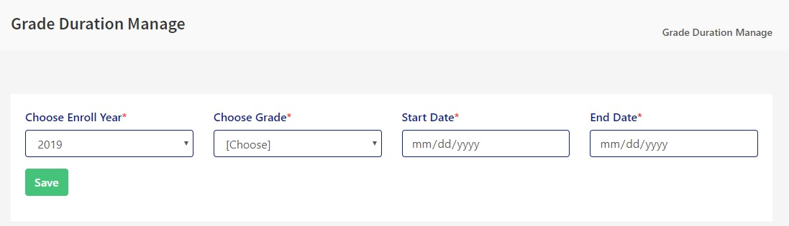

1. **Residential Period Manage**

* Go to **Residential Card Time** under **Getting Start** Heading
* Click **Residential Card Time Period**
* Fill Form and Submit

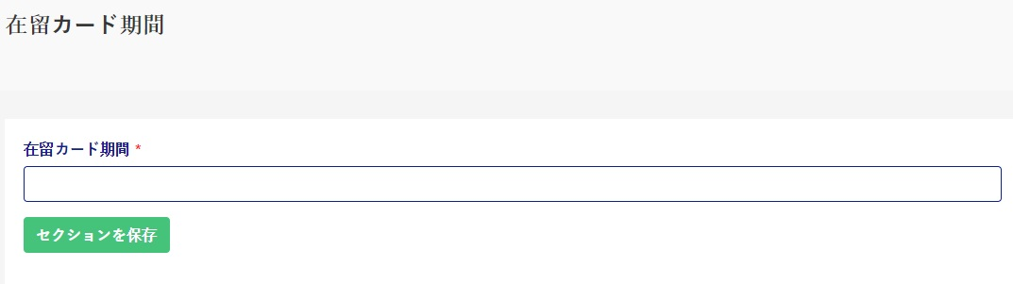

1. **Student Entry Guide**
2. **Student Entry Form**

* Go To **Students** under **Student Manager** Heading
* Click **Add New Student**
* Fill Form and Save

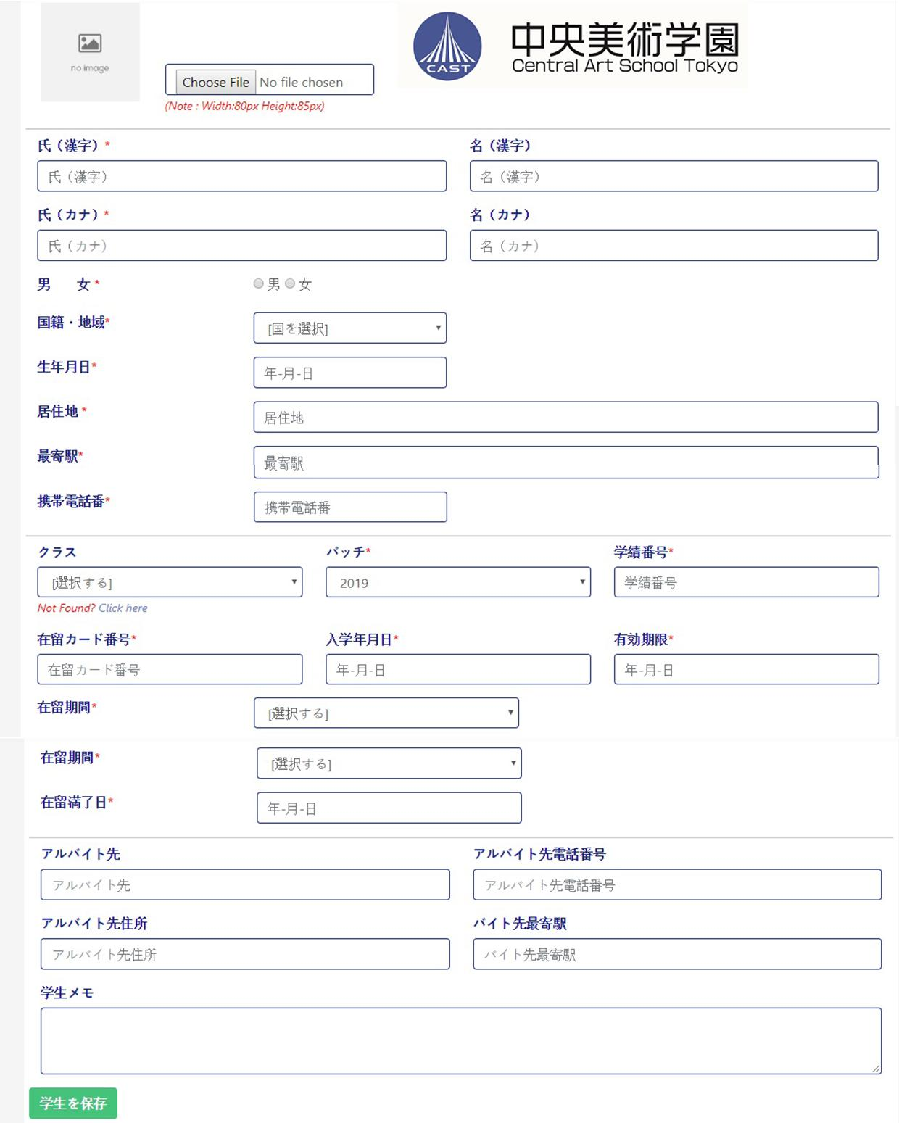

1. **Student Marks Obtain**

* Go To **Students** under **Student Manager** Heading
* Click **Student Marks Obtain**
* Click **Insert Marks** (Top in Right Side)
* Fill Form and Save

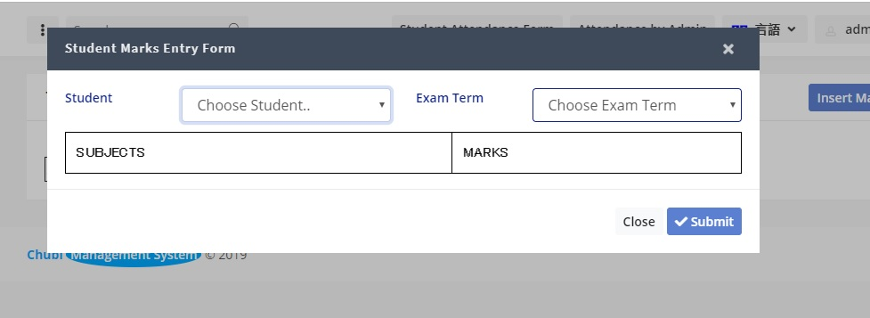

1. **Transfer to Section**

* Go To **Students** under **Student Manager** Heading
* Click **Section Wise (Add)**
* Choose Related Section and Choose Multiple Students for that section
* Save

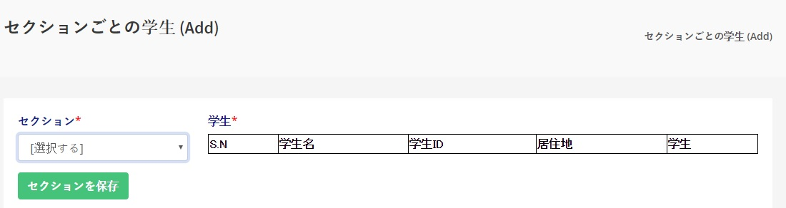

1. **Transfer to Grade Year**

* Go To **Students** under **Student Manager** Heading
* Click **Student Grade Manage**
* Choose Related Grade Year and Choose Multiple Students for that Grade
* Save

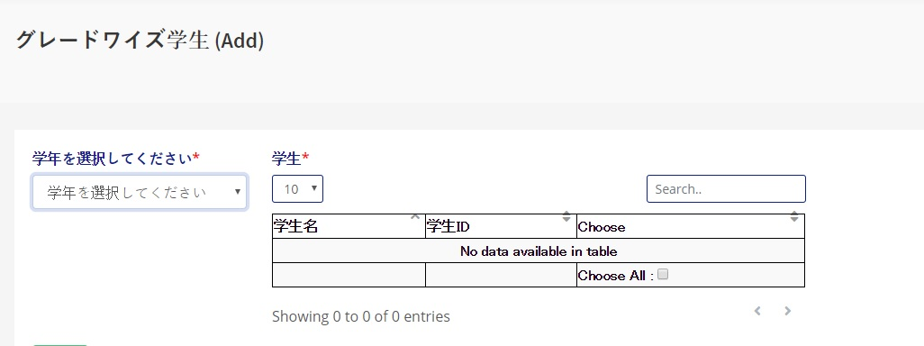

1. **Subject Manage**

* Go to **Subjects** under **Subject Manage** Heading
* Click **Add New Subject**
* Fill Form and Submit

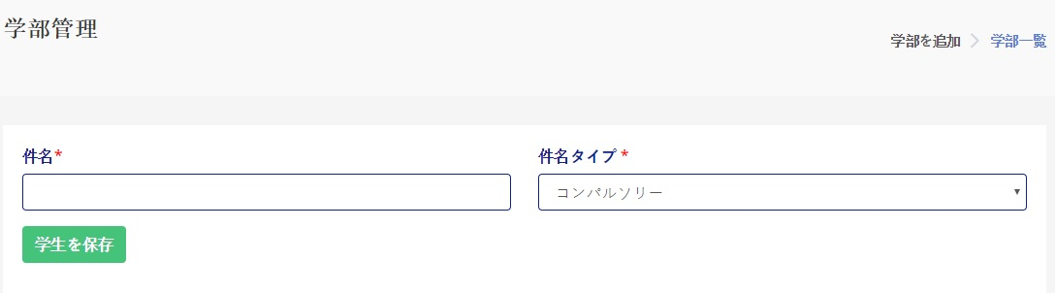

1. **Teacher Manage**

* Go to **Teachers** under **Teacher Manage** Heading
* Click **Add New Teacher**
* Fill Form and Submit

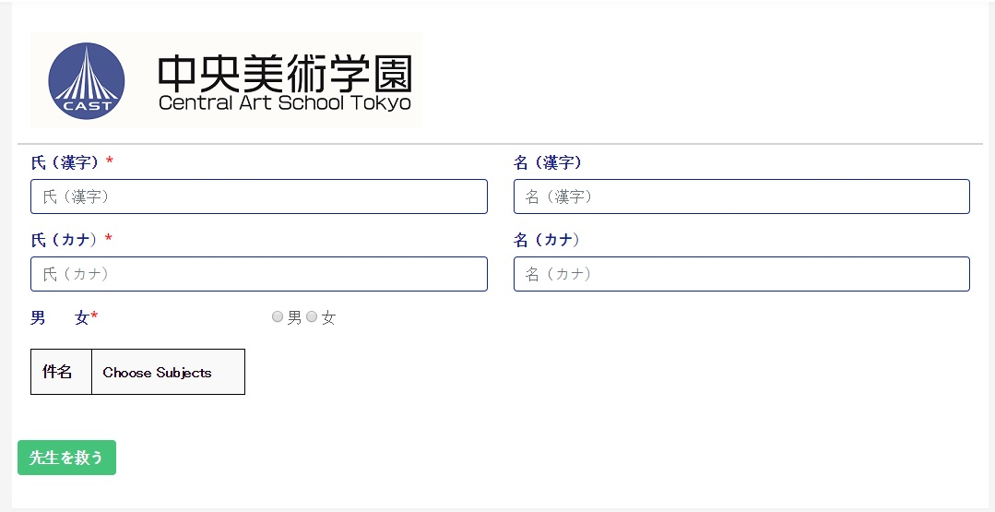

1. **Holiday Manage**

* Go to **Holiday** under **Days/Holiday Manager** Heading
* Click **Add New Holiday**
* Fill Form and Submit

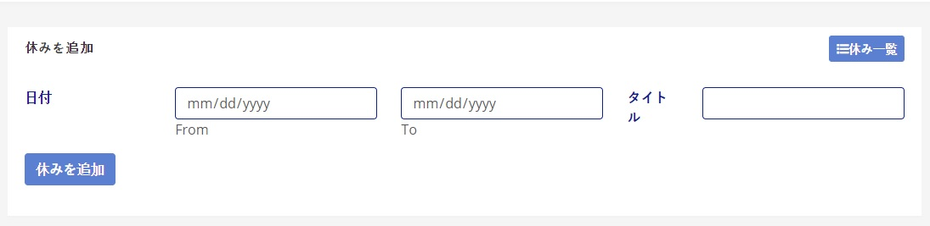

1. **Attendance Manage**
2. **View Attendance**

* Admin Can Make Present/Absent/Late
* Go to **List Attendance** under **Attendance** Heading
* Choose Related Class Batch Section
* Auto redirect to attendance status
* Now admin can make present, absent & late student

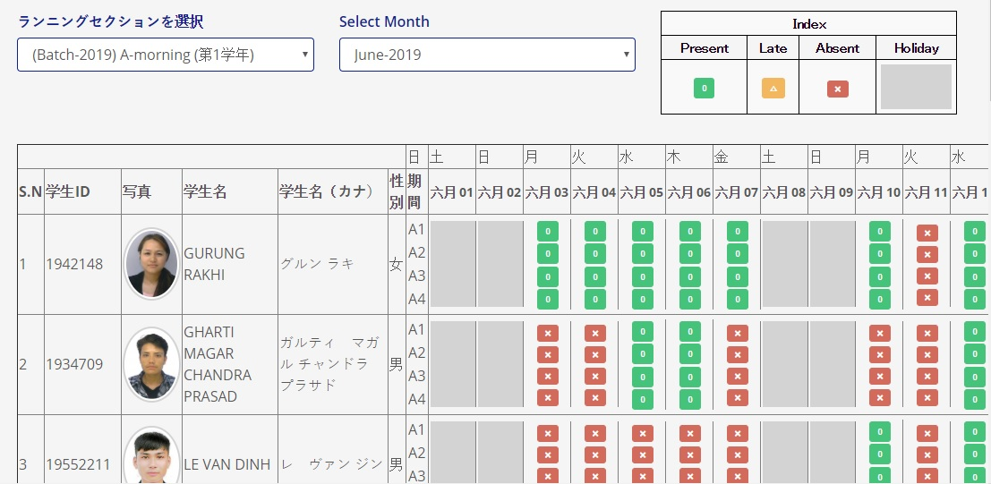

1. **Attendance By User**

* Go to **Attendance by Admin** under **Attendance** Heading ***OR*** **Top Navbar** *“Attendance by Admin”*
* *Choose Related Class Batch Section*
* *Choose Student*
* *Fill related period time and save*

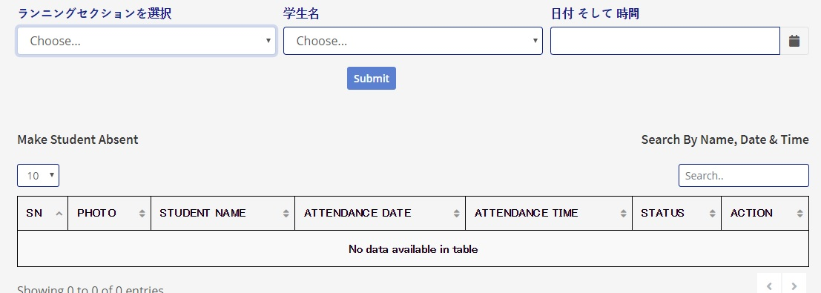

1. **QR Attendance Form**

* Go to **Attendance Form** under **Attendance** Heading ***OR*** **Top Navbar** *“Student Attendance Form”*



1. **Reports View**
2. **Student Immigration Report**

* Go to **Reports** Bottom of **Left Sidebar**
* Click **Student Immigration**
* Now user can choose type of immigration
* Choose Year and click Show

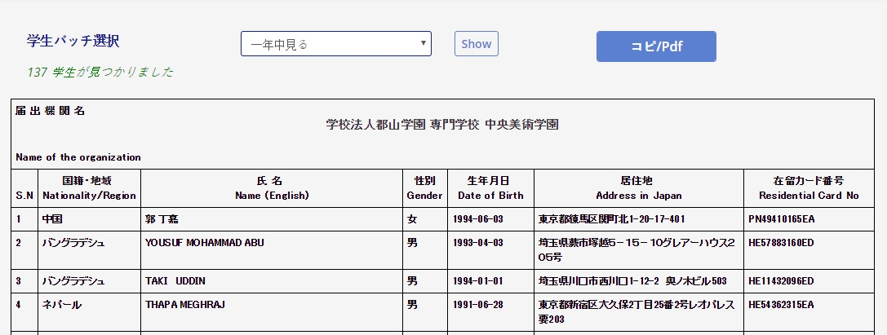

1. **Student Certificate, Id Card & Progress Report**

* Go to **Students** under **Student Manager**
* Click **List Students**
* Click **Download** Dropdown Menu *(Second Column of Student Listing)*
* Choose type of document and open

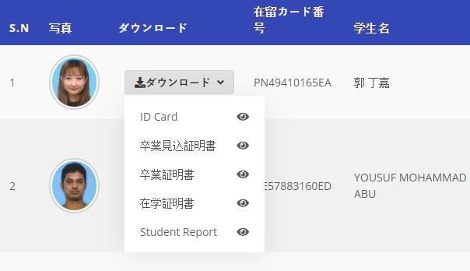

1. **Calendar View**

* Go to **Reports** Bottom of **Left Sidebar**
* Click **Calendar**
* Click View Calendar
* Choose Grade Year and click show

